**Multiple Inheritance**

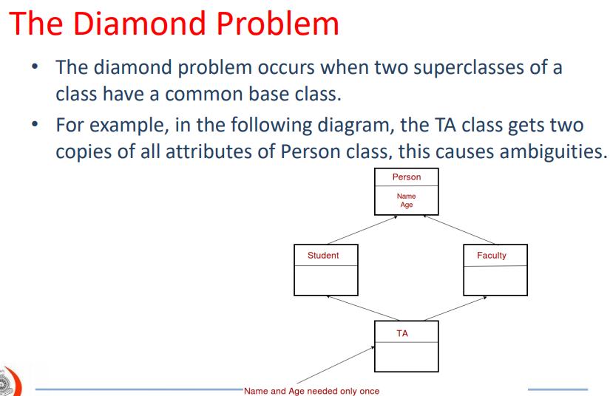

To use base class for multiple sub class and make it inherited there are two methods with just a change of word but the execution of the code is fully different.

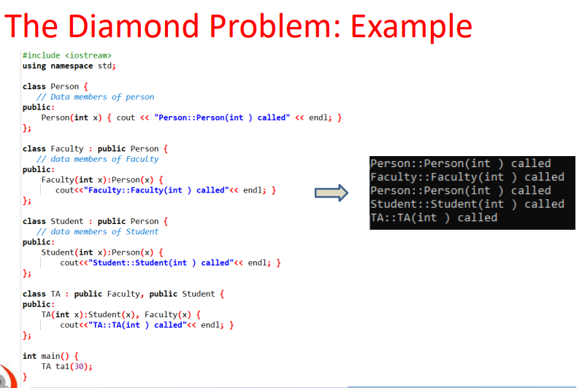

• In the above program, constructor of ‘Person’ is called two times.

• Destructor of ‘Person’ will also be called two times when object ‘ta1’ is destructed.

• Object ‘ta1’ has two copies of all members of ‘Person’, this causes ambiguities.

**virtual Classes**

• One of the solutions to this diamond problem is to create ‘virtual’ classes.

• We make the classes ‘Faculty’ and ‘Student’ as virtual base classes to avoid two copies of ‘Person’ in ‘TA’ class.

• you have to use ‘virtual’ keyword to make a virtual class.